

November 22, 2017

Cillian Mc Neill - 14352621

school of computing

Supervisor: Geoff Hamilton

Functional Specification

MiD Identity Engine

Table of Contents

Introduction 1

Overview 1

Business Context 1

Glossary 2

General Description 3

Product / System Functions 3

Mobile Application 3

Evaluation Component 3

Backend Server 3

User Characteristics and Objectives 4

Operational Scenarios 6

Mobile Application Scenarios 6

Submission Component Scenarios 7

Constraints 8

Security 8

Mobile Operating System Support 8

Speed 8

Ease of use 8

Functional Requirements 9

High Level Design 11

Application – High Level Overview 11

Sequence Diagram – Submission Implementation 12

Sequence Diagram – Verification Implementation 13

Object Diagram – Blockchain Models 14

Preliminary Schedule 15

# Introduction

## Overview

The project I am developing is an identity engine that will aid in proving a person’s identity. It will store information on the user’s mobile device locally and will only be sent out with the user’s permission. The information can be verified by respected institutions and the proof of that verification will be stored with a distributed, tamper-resistant solution called the “Blockchain”.

This system will tackle the problem of identity fraud, where the need for someone to prove who they are in the modern, social-network driven society is incredibly difficult, as many people leave themselves vulnerable by voluntarily exposing very personal information. For me to streamline this into a safe and secure service will not only provide peace of mind to potential users but will save companies, and even countries a lot of money in the long run.

The project will be made up of a backend and two types of clients. These clients consist of an “Individual” and an “Identifying Party”.

* The **Individual** will store personal information in a secure manner. Verification of this information will be initiated by the individual and the appropriate identifying party will be contacted. Requests to verify this information in the future will not require any contact with this party. All records of any verification requests will be stored on the blockchain. This will allow the user to prove their identity in a secure and streamlined manner.
* The **Identifying Party** represents the organisation working with the current identity infrastructure (e.g. issuers of passports, driver licenses, etc.). They will make use of the system to verify information submitted by the user. Information submitted by the user can be compared with what is currently available in their system.

## Business Context

During my time interning with MasterCard, I noticed the need for an identity platform that would allow for companies to authenticate their end-users.  
To have a universal form of identity, recognised by any institution saves time and effort for everyone, especially the issuing institutions. Having a service like this would allow them to work in conjunction, eventually phasing out and replacing different identity documents by a single “master” one. On a case by case basis the system is saving the user hundreds in processing fees and on the large scale it removes the need for numerous institutions, saving the government large quantities of money.

We can see this benefit in a simple example of one person and the need to have a passport, public services card and driver license, alongside many other possible types of identifying documents. A lot of the information on these cards only serves to relay the same information but to a different institution. If the information on these cards were combined and only what is necessary is stored (e.g. name, date of birth, address and relevant ID numbers) then the need for many different forms of identity is removed. Currently institutions do not allow for this functionality, however if the relevant information was provided at birth and updated through a person’s life then the system would operate at peak efficiency.

## Glossary

* **Blockchain**
  + A continuously growing list of [records](https://en.wikipedia.org/wiki/Record_(computer_science)), called blocks, which are linked and secured using cryptography. Each block typically contains a link to a previous block along with any relevant data. Thanks to this and the overall design, blockchains are inherently resistant to modification of the data stored on them.
* **Distributed Ledger**
  + Replicated, synchronized and shared digital data that is spread across multiple locations.
* **Distributed Systems**
  + A model of computer networks in which the systems pass messages to one another to complete a task. The distribution of these systems allows for concurrent work to be done and without a single point of failure.
* **JSON**
  + A format that is easy for humans to read/write and computers to parse. Used in the transmission of messages across a network.
* **Hyperledger Fabric**
  + A branch of the Hyperledger Project (open source blockchain tools and distributed ledgers) originally created by IBM. It is a permissioned blockchain infrastructure using concepts such as roles between nodes and “smart contracts” to facilitate trading.
* **Node**
  + A JavaScript based development platform
* **APK – Android Package Kit**
  + A package file format for the Android operating system.
* **API – Application Programming Interface** 
  + A set of defined methods to allow for communication between various software components.
* **SAFe – Scaled Agile Framework**
  + A form of the agile methodology employed in large organisations. It promotes collaboration and scalability with numerous teams.

# General Description

## Product / System Functions

The programme will be split into four main components. These components will carry out the various tasks necessary to facilitate the identity engine. The system will be composed of a backend component linked into the blockchain network. Clients will use the mobile application and evaluation UI to connect to the backend server which will in turn interact with the block chain. With this, communication between devices through the backend as well as any necessary interactions with the blockchain can be facilitated.

### Mobile Application

The user will store and access their identifying information through this application. They will be able to register any of the supported document types (based on the identifying parties that are registered with the service) and verify them.   
Once verified they can use the application in place of the original identity card. Requests for verification/pieces of these identity cards can be facilitated through this application. Every request, regardless of type, will have to be accepted by the user before it is carried out. This ensures the user has total control of what information people have access to.

An additional feature of the application would be the inclusion of multiple profiles on the same mobile device. Having this would allow the primary user to manage the profiles of secondary users. These secondary users could be the person’s pets or their children.   
The extra profile would function in the exact same way that the original user’s profile would, but it would contain information relating to that user.

### Evaluation Component

Users of this component will be part of an identifying party. Requests to check a user’s validity will come through this, containing the original document and any other necessary information. Using this, it is up to the identifying party to verify the individual. Once verified, they can accept the request through this component and the required transaction between the individual and the identifying party will be added to the blockchain.

While an identifying party will be able to consume the systems APIs to receive submission requests it might not be feasible for them to construct a whole new UI to consume them. To allow larger adoption, a sample UI that they can receive the requests from and just compare it to the original data from their system could be provided. This would not be ideal but in some scenarios, it may be necessary to allow them to transition easily without a complete overhaul to their current infrastructure.

### Backend Server

This server will facilitate communication between an individual and an identifying party. It will also allow for the request of information from an individual and return it back (assuming they have accepted this request). This will be the application’s bridge into the blockchain network, storing and querying requested information.

## User Characteristics and Objectives

The idea behind this system is to provide a quick and easy way for someone to prove who they are as well as allowing identifying parties to verify these individuals. This means that the system will have to be easy to use and understand. While this is true for the average user, extra steps will have to be made to ensure that identifying parties have easy access to this system so that they may carry out their job efficiently. With these ideas in mind, I have created two sample personas. Each one takes the role of an individual from either side of the verification flow.

|  |  |
| --- | --- |
| **Jane** | **Biography:**  Jane is a 28-year-old accountant. She has been in this job for several years, using simple programmes such as word processors on her work computer. She has a smartphone but only uses it for social media and does not quite understand the ins and outs of it.  She has on many occasions forgotten her drivers license at home and as a result has paid numerous fines when stopped. |
|  |
| **Demographics:**  **Age:** 28  **Occupation:** Accountant  **Tech Literacy:** Low | **System Expectations:**   * Application that is easy to set up and install * Does not have to remember a lot of passwords * Able to store multiple forms of identity * The knowledge that her data is secure and nobody can gain access to it |
| **Ken** | **Biography:**  Ken is a 31-year-old employee of the NDLS (National Driver’s License Service). He works in the application processing department, evaluating multiple submissions a day on the company’s web portal. |
|  |
| **Demographics:**  **Age:** 31  **Occupation:** NDLS Employee  **Tech Literacy:** Medium | **System Expectations:**   * No increases workload over what is currently being done within the company * Easy to pick up and start working with within the company’s portal. * Data is secure and interactions are recorded correctly |

With the above personas in mind I have listed out some of the characteristics of the system that would be necessary to deliver a satisfactory experience to both types of users.

* **User Friendly**
  + The mobile interface will need to be as simple as possible so that the user understands exactly what they are doing at any point. This will need to be reflected in the layout of the application along with how the features are described to the user. At no point should the user be confused about what action they need to take.
  + An identifying party will ideally have their own system in place already and all that will need to be provided is another stream of data from another location. While this avoids some of the problems of UI design it must be ensured that the data they are receiving is well formed and easily understood so that they may incorporate it into their current system. This data will ideally be well-formed JSON.
* **Unobtrusive**
  + For the individual user, using this application should be very intuitive. No extra steps should be made in showing identification. It should be as close to showing a physical card as possible. This will have to be brought across in the layout of the mobile application.
  + For identifying parties, the system should ask for no additional work beyond connecting to the system. In the same way that they would process a new identity for someone, it would ask them to simply compare information of a current user to what is being submitted for verification. By not completely changing the workload, we can provide a smooth transition to a new system.
* **Speed**
  + Above all else, this must be as quick as possible for the individual user. For it to truly replace a physical card it must be as quick as showing that card. Further verification will require extra time, but a request for information from a user should be easily and effortlessly accepted and sent on with next to no delay. By doing this, the system will be as close as possible to having the physical card.
  + Identifying Parties will be dealing with hundreds of requests at any one time. It would be extremely important for us to ensure that the workload is manageable and processed in as quick a time as possible.
* **Security**
  + As this application will be handling very sensitive data for the user, it is imperative that they know it is being done in a secure manner. The application must allow the user to secure it through a password or biometric lock.   
    Having the additional step to get into the application and their information will go a long way in comforting the user. Steps will also need to be made to ensure the user knows that no information leaves their device without them knowing.
  + Identifying parties will have a deep concern for the security of their data. It will need to be ensured that submitted requests are secured in such a way that external access to this data would be extremely difficult to obtain.
  + Data stored within the servers of the application will need to be encrypted and unreadable by anyone but the intended party. Once requests have been submitted and processed there will be no reason to keep the submitted data as long as there is a record of what passes through the system.

The above characteristics are not unrealistic to expect from such a system. While there are no specific choices that will dictate how the system will incorporate these features, they will need to be at the forefront of every design choice made.

## Operational Scenarios

The system, from an end user perspective, is divided into two components. The mobile application for the individual to store their information and the web based component for identifying parties to process validation requests. Due to the division outlined above, the proposed scenarios will be divided in that manner.

### Mobile Application Scenarios

1. **Registration**
   * A user, when first setting up the application, will need to register an initial form of identification. No verification is necessary at this point but for further use of the application it is required. The user must enter the information on the relevant identification card. Once saved it can be accessed at any point.
2. **Verification**
   * If the user wishes to use a form of identification through the application then they must verify it. They will submit the entered information of that form of identification along with a current image (if applicable).
3. **Additional Identification**
   * If the user wishes to store more than one form of identification then they may follow the same steps as they did during the initial registration. Again, verification must be completed before actual use of that identification.
4. **Requests for Information**
   * If a third-party application requires some form of identifying information, they may ask a user for it through this system. By requesting a link to the user’s profile, they can send a request for the information desired. This request is handled by the mobile application. It will let the user know what is being requested along with who is requesting it. This request can then be accepted or rejected by the user.
5. **Requests for Validation**
   * If a user has a form of verified identification they may be challenged to prove that it belongs to them. This can be done through querying the blockchain for the original transaction. By proving ownership of that transaction, the validity of the information being challenged can be proved.

### Submission Component Scenarios

1. **Submission Processing**
   * Requests for validation can be requested from the submission component of the system. Information tied to that submission can be viewed and processed in a way suited to that identifying party. This can be in the form of comparing submitted information to what is stored on the system, such as the card ID numbers or pictures.
2. **Submission Acceptance**
   * If a submission has met the identifying party’s acceptance criteria, then they can mark the submission as verified. This verification is stored publicly, and the individual is notified.
3. **Submission Rejection**
   * If for some reason, the submission does not meet the party’s acceptance criteria then they can mark it as rejected and return that result to the individual.

## Constraints

Below lists some of the constraints that are placed upon the system. These points should be included in any system altering decision.

### Security

Regardless of where the data is within the application (stored locally, as part of a verification submission or in transit from a request) it is important that the data may only be read by its intended recipient. Anything less than that is a failure due to the sensitive nature of the data. This will need to be done through a form of cryptography such as public key cryptography.

### Mobile Operating System Support

As this is an application that will be used by a wide variety of devices it is important that a majority of them are supported. Android support will be for version 5.0 and upwards due to the large market share of [about 75%](https://fossbytes.com/most-popular-android-versions-always-updated/). Due to time constraints, there will only be an android version in the initial release and an IOS version can be released at a later date.

### Speed

While submission review is out of the application’s hands, it is important that any other requests made to the system are handled in a timely manner. Requests for information are one of the more important examples here. It is important that a user sees little to no delay from clicking a button on another application and receiving a notification on their phone.

### Ease of use

This application is handling very sensitive data so it is important that the user knows what they are doing at any point. Descriptions and error messages should be concise and address exactly what the user is doing and what they should do next. This will allow for a more enjoyable experience within the application.

# Functional Requirements

This section lists the functional requirements in ranked order of importance. It describes what the system must accomplish overall.

|  |  |
| --- | --- |
| **ID** | 1 |
| **Description** | The system must be able to communicate/store data in a secure manner. |
| **Criticality** | This is a key requirement as the data being communicated is very sensitive. |
| **Technical issues** | This involves implementing cryptography methodologies relevant to the data and how it is being communicated/stored. |
| **Dependencies** | N/A |

|  |  |
| --- | --- |
| **ID** | 2 |
| **Description** | The system must be able to update appropriate data stores whether local or remote. |
| **Criticality** | Being able to store the information in the application is required for it to function correctly. |
| **Technical issues** | It is imperative to ensure the database used is correctly formatted and accessible. It will conform to at least the third normal form. In addition to this, there will need to be work done to ensure that data stored on the mobile device is placed in a logical and secure location. |
| **Dependencies** | This depends on requirement 1 as data being stored must be secured. |

|  |  |
| --- | --- |
| **ID** | 3 |
| **Description** | The backend must be able to communicate with an individual. |
| **Criticality** | To allow the user to be notified when necessary it is important that the system can contact them. |
| **Technical issues** | Using Google’s Firebase messaging service will require configuration and setup. |
| **Dependencies** | This depends on requirement 1 and 2 as the data transmitted must be secure and will need to be stored in some way throughout this communication. |

|  |  |
| --- | --- |
| **ID** | 4 |
| **Description** | The mobile application must be able to store multiple forms of identification. |
| **Criticality** | While the application should work with one form of identity, it is important that it can allow the user to have multiple forms of identification in case there is extra information that is required. |
| **Technical issues** | Ensuring the data is correctly divided and displayed in a logical order within the mobile application will be a concern. |
| **Dependencies** | This depends on requirement 1 and 2 as multiple forms of identification must be stored securely and logically on the device. |

|  |  |
| --- | --- |
| **ID** | 5 |
| **Description** | The identifying party must be able to retrieve all applicable submissions. |
| **Criticality** | To allow for quick and easy retrieval and review of submissions the backend must be able to return submissions applicable to each identifying party. |
| **Technical issues** | Ensuring the data is correctly labelled for the correct party and access control is implemented on the backend will be necessary. |
| **Dependencies** | This depends on requirement 1 and 2 as submissions must be stored/returned securely. |

|  |  |
| --- | --- |
| **ID** | 6 |
| **Description** | The identifying party must be able to mark submissions stored as valid/invalid. |
| **Criticality** | For the overall application to function as intended it is important that identifying parties can say whether information submitted is valid or not. |
| **Technical issues** | Ensuring the data is available to the party and they are able to edit individual submissions will allow the application to carry this task out. |
| **Dependencies** | This depends on requirement 1 and 2 as submissions must be stored/updated in a secure manner. |

|  |  |
| --- | --- |
| **ID** | 7 |
| **Description** | The blockchain implementation must have correct models and interfaces in place. |
| **Criticality** | To track any successful verification transactions, models and interfaces must be in place on the blockchain. |
| **Technical issues** | The creation of node interfaces along with the JavaScript implementation of the models in the Hyperledger Fabric Ledger will allow any transactions to be created, updated and queried. |
| **Dependencies** | This depends on requirement 1 and 2. The blockchain itself is public but data transmitted to the blockchain must be secure. |

|  |  |
| --- | --- |
| **ID** | 8 |
| **Description** | It will provide support for a variety of Operating Systems. |
| **Criticality** | To allow for a wide adoption of the system it is important that it can run on as many devices as possible. |
| **Technical issues** | Ensuring correct code convention is followed regarding backwards compatibility is necessary here. |
| **Dependencies** | N/A |

# High Level Design

Below lays out a high-level overview of how the system functions. This will include the main system layout and sequence diagrams to describe the key functions of the system.

### Application – High Level Overview

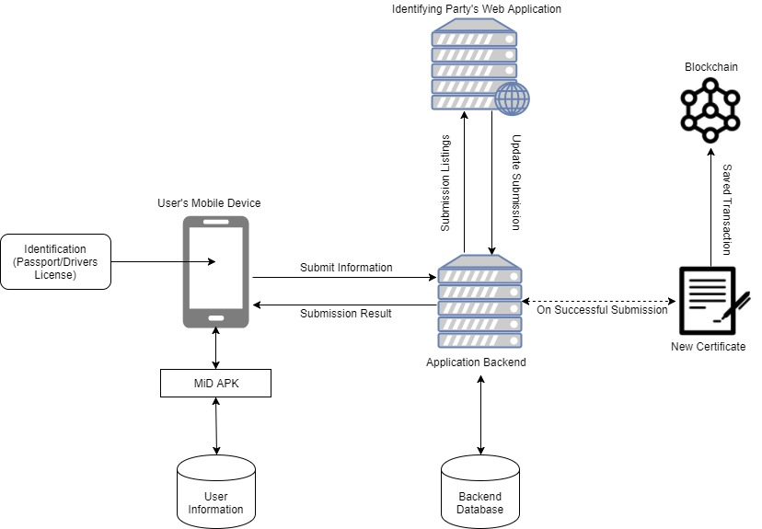

Above draws out how the main components of the system will function and how they will communicate. A mobile device will be the main channel through which an individual will make and answer requests.   
An identifying party will interact with the system through their own application. They will pull down any requests made to their service and evaluate them. Results of this evaluation are sent back to the system. Any successful submission is carried over to the blockchain in the form of a new certificate in the submitter’s name.  
Any other relevant information is stored on the application’s backend. This will include information that will allow the system to communicate with an individual’s device as well as information linking to an individual’s currently pending submissions.

### Sequence Diagram – Submission Implementation

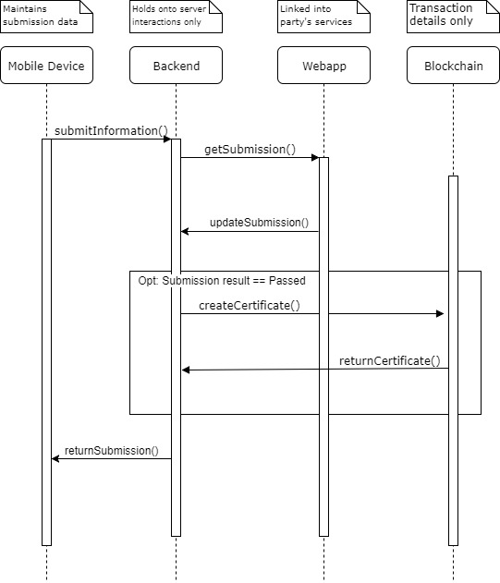

Above is the sequence in which a verification will be carried out. This is the main form of communication that will occur in the system, as an individual will need to do this before using any form of identification within the application to verify themselves.   
A submission is made to an identifying party. These submissions can be retrieved through the identifying party’s web application. There, they will make the decision whether to accept or reject the submission. If accepted then the details of that verification are submitted to the blockchain and a certificate of identity is created. Regardless of the verification status the user will receive a result of the verification process.

### Sequence Diagram – Verification Implementation

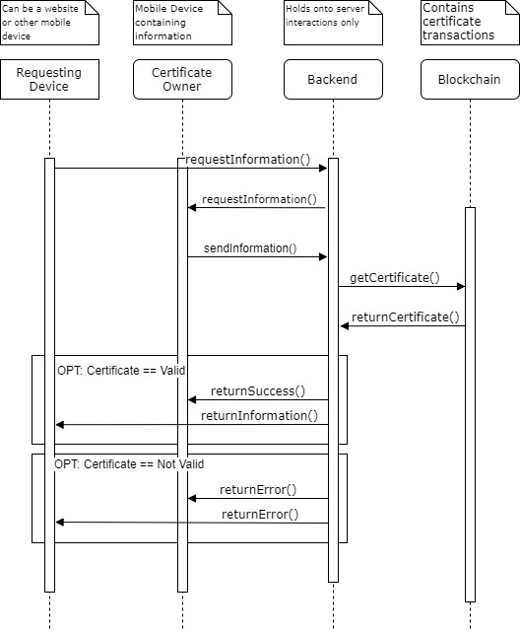

Above describes the sequence in which someone can request and verify information. A third party can request information from a user (assuming they know their ID within the backend) and that request is relayed on to that specific user. Assuming they agree to the request, the information and a reference to the certificate that was given during the submission of that information is sent back. The certificate is queried from the blockchain and compared against what has been submitted. If the information matches what is in the certificate, then it is relayed back to the requesting party along with a reference to the certificate. If there is an error in the comparison, then a notification is sent to both parties.

### Object Diagram – Blockchain Models

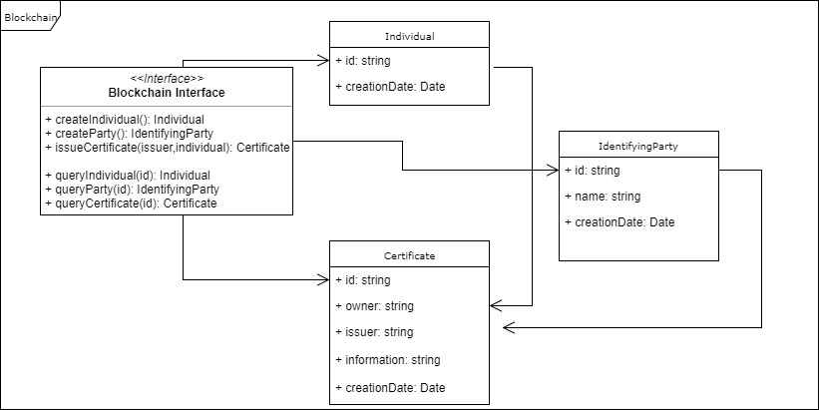

The above diagram illustrates the way in which data will be stored and interacted with in the blockchain. An interface will be in place to allow for smooth interaction between external applications and the blockchain. The data itself is replicated across many nodes and access control of the interface will be implemented to allow for legal interactions to take place.  
From the previous sequence diagrams, it can be seen that there are calls in place to allow for the interactions necessary for the system to function.

# Preliminary Schedule

For the duration of the project I will be following the Scaled Agile Framework (SAFe) approach. This is a form of Agile development that I am familiar with from my time at MasterCard. It will allow me to work quickly and in a structured way, while also providing updates in the form of blog posts and meetings with my supervisor.

To structure my Agile approach, I am using [Trello](https://trello.com/). The cards in this application will act as the stories I will be working on. Each story will contain updates and any relevant information that I can point back to or build upon.

I have approximated that I have 25 weeks of work time that I can put towards the system. I will be working on as many tasks in parallel as possible so that I can complete it within the time given. I will also be reducing the number of tasks near the end of the timeline so that I may push forward tasks if there are difficulties or other priorities at the time. Below is the Gant chart visualising this.

### 

|  |  |  |  |  |  |  |  |  |  |  |  |  |  |  |  |
| --- | --- | --- | --- | --- | --- | --- | --- | --- | --- | --- | --- | --- | --- | --- | --- |
| Project Starting 09/10/17 | Week 1 | Week 2 | Week 3 | Week 4 | Week 5 | Week 6 | Week 7 | Week 8 | Week 9 | Week 10 | Week 11 | Week 12 | Week 13 | Week 14 | Week 15 |
| Requirements Planning |  |  |  |  |  |  |  |  |  |  |  |  |  |  |  |
| Design Analysis |  |  |  |  |  |  |  |  |  |  |  |  |  |  |  |
| Project Planning |  |  |  |  |  |  |  |  |  |  |  |  |  |  |  |
| Project Proposal |  |  |  |  |  |  |  |  |  |  |  |  |  |  |  |
| GUI Prototype |  |  |  |  |  |  |  |  |  |  |  |  |  |  |  |
| Functional Specification |  |  |  |  |  |  |  |  |  |  |  |  |  |  |  |
| Mobile Prototype |  |  |  |  |  |  |  |  |  |  |  |  |  |  |  |
| Web App Prototype |  |  |  |  |  |  |  |  |  |  |  |  |  |  |  |
| Backend Prototype |  |  |  |  |  |  |  |  |  |  |  |  |  |  |  |
| Blockchain Models |  |  |  |  |  |  |  |  |  |  |  |  |  |  |  |
| Blockchain Implementation/Linkage |  |  |  |  |  |  |  |  |  |  |  |  |  |  |  |
| Overall Prototype Build |  |  |  |  |  |  |  |  |  |  |  |  |  |  |  |
| Initial Testing |  |  |  |  |  |  |  |  |  |  |  |  |  |  |  |
| User Testing |  |  |  |  |  |  |  |  |  |  |  |  |  |  |  |
| Mobile Build |  |  |  |  |  |  |  |  |  |  |  |  |  |  |  |
| Web App Build |  |  |  |  |  |  |  |  |  |  |  |  |  |  |  |
| Backend Build |  |  |  |  |  |  |  |  |  |  |  |  |  |  |  |
| Blockchain Build/Linkage |  |  |  |  |  |  |  |  |  |  |  |  |  |  |  |
| Overall Build |  |  |  |  |  |  |  |  |  |  |  |  |  |  |  |
| Documentation |  |  |  |  |  |  |  |  |  |  |  |  |  |  |  |
| Blogging |  |  |  |  |  |  |  |  |  |  |  |  |  |  |  |

|  |  |  |  |  |  |  |  |  |  |
| --- | --- | --- | --- | --- | --- | --- | --- | --- | --- |
| Project Starting 09/10/17 | Week 16 | Week 17 | Week 18 | Week 19 | Week 20 | Week 21 | Week 22 | Week 23 | Week 24 |
| Overall Build |  |  |  |  |  |  |  |  |  |
| Code Review |  |  |  |  |  |  |  |  |  |
| Full Implementation Testing |  |  |  |  |  |  |  |  |  |
| User Testing |  |  |  |  |  |  |  |  |  |
| Testing Writeup |  |  |  |  |  |  |  |  |  |
| Documentation |  |  |  |  |  |  |  |  |  |
| Blogging |  |  |  |  |  |  |  |  |  |